**Table of Contents**

**Overview of Program Pg 2**

**Program Structure Pg 3**

**Description of each Function Pg 4**

**Description of Data Structure Pg 5**

**Global Variables Pg 6**

**Cross References Pg 7**

**Index Pg 8**

**Overview of Program**

The system is a simple operating system that is still in development. The current functionality is still very limited but the current plan is to progress with the project and improve the Operating System.

**Program Structure**

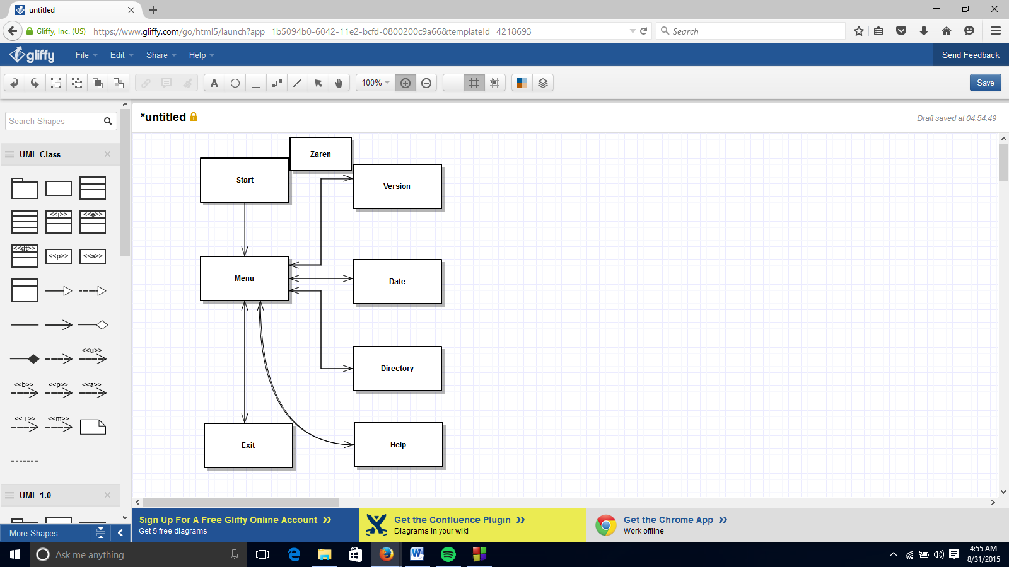

**Description of Functions**

Start: No parameters. No return value. Starts up the OS and then moves to menu.

Menu: No parameters. No return value. Directs user around Operating System.

Version: No parameters. No return value. Displays version and returns to menu.

Date: No parameters. No return value. Displays date and time and returns to menu.

Directory: No parameters. No return value. Displays all file in current directory.

Exit: No parameters. No return value. Prompts user for confirmation to exit and then either returns to menu or exits program.

Help: No parameters. No return value. Displays information on other commands.

Test: No parameters. No return value. Quick rudimentary test of system.

**Description of Data Structures**

**Global Variables**

**Cross References**

**Start:**

Calls: Menu

Called by: N/A

**Menu:**

Calls: Menu, Version, Date, Directory, Help, Exit

Called by: Start, Menu, Version, Date, Directory, Help, Exit

**Version:**

Calls: Menu

Called by: Menu

**Date:**

Calls: Menu

Called by: Menu

**Directory:**

Calls: Menu

Called by: Menu

**Exit:**

Calls: Menu, Exit

Called by: Menu, Exit

**Help:**

Calls: Menu

Called by: Menu

**Index**

DatePg 3, 4, 7

Directory Pg 3, 4, 7

Exit Pg 3, 4, 7

Help Pg 3, 4, 7

Version Pg 3, 4, 7